In the Interim – Aboard Sengo – October 2014

1st October 2014

This morning I spent half an hour in the engine bay lying on my back, my legs straddled around the steering arm, trying to avoid fibreglass dust as the drill bit pushed through from the outside. It was not comfortable!

We have spent the last week at the end of the jetty where some warranty work has been completed, some new issues have been found (approval not yet given), a couple of loads of washing have been done, my tooth has been fixed by a second trip to the dentist and we’ve been talking to contractors about canvas to enclose our back cockpit in, and the provision of out door cushions.

Tomorrow, however, we have to leave to make way for another boat so we’ll head back into the vicinity of the national park. We had two extra batteries installed today so hopefully we’ll notice a difference (double our capacity). We are also negotiating with a sign writer to put a name on the boat and the relevant registration number (the registration number is a legal requirement and should be done sooner rather than later). It has only taken us 2.5 months!

I suppose the biggest news of the week is that the Mac repair shop found nothing wrong with my computer. Zip. Nada. They ran a full program of diagnostics over 72 hours apparently and nothing untoward happened. I just hope that it was a once (twice, three times) off glitch. I fear it was not. A screen dump will give them more info if it happens again. Lets just hope it doesn’t.

2nd October 2014

There is a lesson in everything and I have discovered it is always a good idea to put the salt back in the same place. Otherwise you end up picking up the pepper instead and grinding it into the mix of what are supposed to be sweet muffins. Whilst the muffins are in the oven and the sun is threatening another lovely sunset (unfortunately encouraged by the smoke of nearby bushfires and not light cumulous clouds), I can tell you that we had a lovely afternoon sail up Pittwater and around to our favourite America Bay. I’d like to also tell you that we achieved our highest sailing speed yet (8.4 knots) but we have grown particularly suspicious of the gauges after we discovered that they are not calibrated (we have three different instruments with bearings out by 9 degrees). We are expecting to get this looked at (and hopefully fixed) in a couple of weeks (which may or may not be the next time we head back to RPAYC for shipwright warranty items). This afternoon we introduced the cats outside on the harness together. Both headed back inside rather quickly. Cilla went back to her spot on the couch but Tiger eventually got curious enough to step outside on his own and we followed him around the boat while he explored his new surroundings.

America Bay is starting to fill up – in fact we are surprised there are not a greater amount of boats here. It is the end of school holidays and a long weekend coming up. Ah, but it is only Thursday. Tomorrow night may be a better indication – but I suspect we may have moved on by then.

5th October 2014 - More Sage Lessons from the Kitchen

We have been anchored here between Halletts Beach and Cottage Rock since 4pm yesterday. It should technically have been 3pm yesterday but we are still perfecting our anchoring technique and we found the anchor was ‘falling upside down’ as we lowered it thought the water. After several attempts at several different spots she finally took - a little further out than ideal and therefore a little more affected by swell and bow waves. Thankfully overnight conditions were calm and you would not have guessed you were on the water at all.

It is a long weekend at the end of the holidays and the amount of boats around here is disconcerting (I’d hate to think how many there would be at the more popular spots – I wouldn’t be surprised if all available space was full) The forecast for today was 32 and there has been no shortage of sunbathers on decks and the Cottage Rock beach (at least until the tide came in). It is now 4.30pm and the ‘sea state’ has calmed to a few boats travelling up the creek, as opposed to the myriad of jet skis, tenders and ski boats towing people and boards just to the west of us during most of the day.

The most novel occurrence of the day was the Take Away boat that chugged past, plaques on the side of it advertising newspapers, ice cream and coffee. In comparison to that the little boat advertising prawns and mussels seemed quite normal.

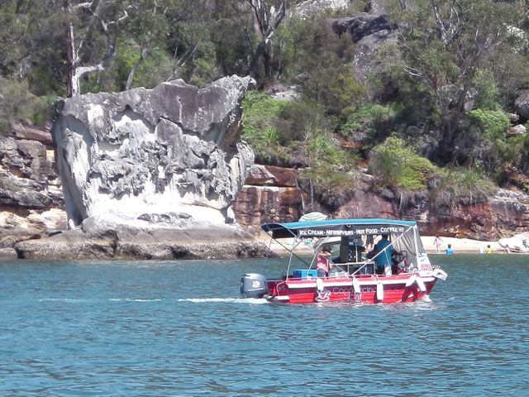

At about mid afternoon I’ve been getting into the semi habit of making afternoon tea. At this stage my repertoire hasn’t gone beyond muffins - as they are quick to prepare (a couple of minutes) and quick to cook (15 minutes). Today I thought I’d make the chocolate mouse I’ve had my eye on (which has to set overnight so I won’t be able to enjoy it until tomorrow) and will nibble nuts for afternoon tea instead.

There was hardly any need to melt the chocolate over flame (it was hot enough inside so a metal bowl was all that was needed) but I was reduced to a whisk to beat the egg whites (having no idea at this stage where I’d put my electric beater, if in fact it has actually made it on board in the first place). Eggs whisked and chocolate being gradually added I put the bowl on the bench to give my attention temporarily to something else when a large bow wave hit. Suddenly thrown off balance to the starboard side of the boat I adjusted my stance. The whisk however has no way of doing this and bounced out of the bowl onto the bench flicking chocolate egg white with it. Rescued and back to mixing, I wiped the bench, added more chocolate, whisked again and again turned my attention to something else …to be again hit with a large bow wave (ordinarily this is a comparatively steady boat). The whisk again flipped itself onto the bench, chocolate again flying onto the bench, onto the stove and onto me. Rescuing the whisk for the second time I wiped down my elbows and my t-shirt, put the whisk back into the bowl and the bowl into the sink. I was determined not to lose any more of the mixture. I was skimming it enough with sugar free chocolate….but I was determined to consume as much of the stuff as I could get.

7th October 2014

If you are going to be a good Samaritan…for Dogs sake do it quickly. Andrew had been watching a vessel in trouble for some time before I asked what he was looking at. Three people were trying to paddle a fishing boat whose motor was clearly not working. They were drifting out with the tide. ‘We should help them,’ I said. ‘With what?’ was the reply. ‘I’m keeping an eye on them.’ ‘It’s getting late and we should help them.’ The problem was our tinnie was too small to be of any use. I wanted to send A over there to at least see if they wanted help – his argument was that our tinnie was too small to be able to tow the vessel back and by the time we got back it would be dark. We finally decided to take the big boat over instead. I didn’t want to tow anything in the dark but really all we had to do was get these people on board – we had beds and food and could anchor and deal with the logistics in the morning.

So as it was now close to twilight we raced to get the anchor up. To cut a long story short, we tripped the anchor winch three times, losing valuable time; I got covered in mud and just as our anchor was up Andrew turned around to find another Good Samaritan had gone to their rescue. We were now not needed and no longer attached to anything – mildly cursing we went about laying the anchor again and failed twice. The third time however it held. It was now very close to dark. And we were very close to frazzled.

On a completely different note, I have a slightly disgruntled cat. We introduced Tiger to the outside via the front cockpit (on a lead) at the RPAYC. I didn’t actually want to do this at a place with too many distractions and hazards (particularly since I heard someone lost their cat by being spooked there last Christmas) but as it was hot and we wanted some airflow he got particularly interested in the open front door. Cilla, at that point wouldn’t come near the door. As explained earlier at America Bay we supervised (ie followed) Tiger search tentatively around the deck (Andrew offering to jump after him should he go overboard) and Tiger enjoyed and evening and morning of this supervised freedom. However, as we are now in National Park Waters, I have not let him out the door and I’m sure he’s wondering why, I’m not sure its possible to install National Park ethics on a cat, although I notice it doesn’t stop others from walking and letting their dogs defecate on National Park soil.

8th October 2014 – Pinta Bay

It is a bit sad that the one who grabs a bite first go at the bread mixture you make up is a baby bream (well undersized, and my first bream but not bad for the first throw of the day) whereas my husband wont touch it when it has been cooked into bread. My third try at damper wasn’t a complete disaster but more refinement (and a longer cooking time than recommended) is needed. Perhaps I should just make the dough and go fishing instead!

The marine forecast was 70% chance of rain, which it did this morning. It seems to have cleared up since then and there is a smidge of blue sky showing through. Tomorrow, hopefully, a bushwalk to Coawn (pronounced cow – anne).

There is something quite serene listening to casual jazz wafting out from the boat on the next mooring whilst watching a lone fisherman casting into the end of the bay, overlooked by a pair of black and white, white-bellied sea eagles and sitting on a surface of reflective glass.

10th October – Pinta Bay – 11am

There is nothing quite like dragging a 120kg boat through sucking /drying sand to let you know that you are definitely not fit or strong enough for the task. There were two of us undertaking this task around 3.30pm yesterday and I can tell you it wasn’t easy, wasn’t fast (involved a few stops, painfully aware that the longer we stopped the further we were going to have to pull) and this morning my muscles are slowly seizing up letting me know that they exist. In comparison to this the walk from the end of Jerusalem Bay to Cowan was a doddle – even the tiring steep bits at the Cowan end (where I do admit I stopped once or twice to catch my breath).

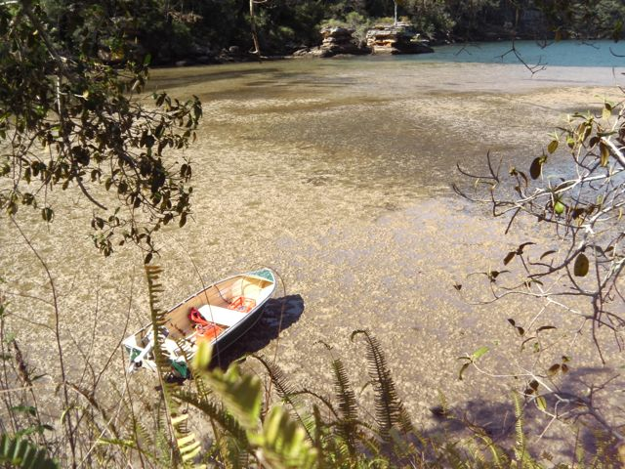
Contemplating the drag

The majority of the walking track was delightful – typical back track dotted by logs and stones, occasional falling of water heard (but not seen) and birds…well, your couldn’t turn around without seeing and hearing forest birds.

We’ve had a challenge over the last week or so; and that was to see anything smaller than a currawong. Admittedly our observations have been from the boat but sitting in bays you tend to see the big things: cormorants, white-faced herons, black cockatoos, whistling kites and sea eagles. We heard a few small ones – the whip bird is obvious – but we’d rarely seen anything more than a flash of movement – if we were lucky. We had actually got past this challenge in the past day – a king parrot and a little wattle bird - but they were only two. In the forest there were birds everywhere. Honeyeaters, pardalotes and thornbills to name the most prolific. And of course we heard the whipbird. An indigenous boronia was also pointed out to me by a fellow walker – apparently it only grows in the valley of the track.

12th October 2014 – Sunday – Snapper Rock Bay

9.30am Beautiful sunny day and fog has just lifted. Yesterday was a day of first for me. My first swim in the cold waters of 11m depth. My first paddle on the kayak – although we had to break it apart from when Andrew last used it - to put the centre bit in to make it acceptable for two people. This took longer than we thought as we think the salt water has affected the clips.

The bream are at least getting bigger – stull undersized though – but it was nice to know I could catch something as I haven’t caught anything since the salmon. However, this almost seemed like a consolation prize as we’d earlier watched a pair of fisherman fish the edge with squidgees and regularly pull up flathead. Last night when we went to bed a large school of fish was teasing us; we could see their bulk as they jumped out of the water in the moonlight.

The latest big job was yesterday morning: lets just say it involved a holding tank, a full indicator light that wasn’t working and a crack in the tank inspection hatch – I’ll leave the rest to your imagination.

Morning: Snapper Rock Bay
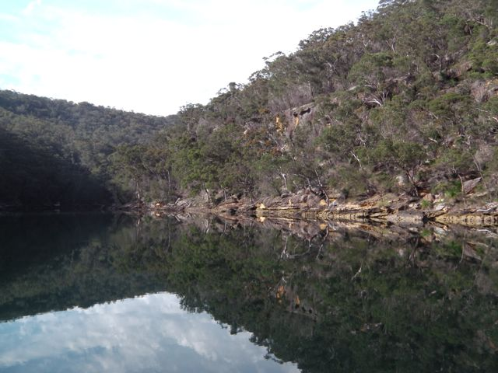

14th October 2014

Well today’s big job was defrosting the fridge. In truth, I’ve known about the need to carry out this task for quite some time (a couple of months) as it was upon investigation of water dripping onto my goods in the fridge that I discovered the unwelcome icy chunks above. However, this was only a couple of days after I had packed the freezer full of meat (and I mean full) so I was not quite happy with the thought of defrosting all that meat then refreezing it again (some of which was fish!). So the only thing was to get the job done when I ran myself out of food (this task was delayed a few extra days as we had vegetarians staying on board for 5 days). However, the stock depleted (minus tonight’s meat and vegies and some frozen bait (not too worried about refreezing that) and I turned all the power off at 10am…

…and went for a paddle. We are at the end of the navigable section (for big boats) at Smiths Creek and unlike the ends of many bays in this area this one doesn’t dry up. We dropped the kayak, with the Go pro strapped to the front, and headed off to where we could see the end. About 45 minutes later we turned around; mainly because the channel was becoming thinner and clogged with sunken logs and trees. The scenery went from the high cliffs typical of these anchorages to mangrove trees and opened up into a treed valley. It was a very pleasant paddle and I surprised myself that I found a technique that didn’t strain my arms or my back. I found though that I didn’t see all the journey had to offer and Andrew would point out something in the water which I’d miss because I was looking at the escarpment above me. The highlight was a large blue groper/wrasse (which unfortunately I didn’t get a photo of). Once back Andrew managed to swim around the starboard rudder and release a stuck fishing line (or broke it off where we could )(I can’t say anything, I managed to send a nice blue lure flying to a water grave yesterday) before we had leftovers for lunch. I then contemplated the fridge.

The job is done now, this ice gone (as well as a chux that was stuck in there somehow from an earlier clean (not mine)) and the greasy finger marks wiped off the door. (I was embarrassed to discover the other day I’d shown someone over our boat with my fingerprints reflecting and obvious).

Now – tomorrow – desperate for shopping. And we all know that with my history of the task – that could mean anything.

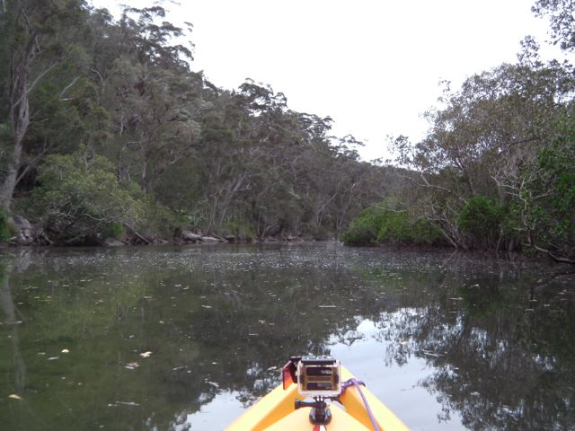
Paddling up Smiths Creek

30th October 2014

4pm. There is a batch of muffins in the oven. These are the first muffins I’ve baked since the ‘project ‘ began and whilst I’m not quite finished the project it is, I think, time for muffins.

The shopping trip predicted in the last entry was delayed by a day due to weather. During this 24 hour hiatus we ha a couple of quotes come in for couch covers and seating. And gobsmacked we were! Whilst we decided that it would be best to get the professionals to make the outside cushions we decided that I would have a go at the covers of the indoor seating myself (a very necessary exercise if we are to protect the original covers from cat claws).

Whilst I know where the Dee Why Lincraft store is, (on a bus line we had used to get to Manly for a day out) I decided that was more comfortable finding my way around a Spotlight store (the number of Lincraft stores having reduced dramatically in Melbourne to the point of near non -existence) and ferreted at yellow pages online to find our nearest (read, most easily get-to-able) Spotlight Store. So on the Thursday we motored back to Brooklyn, waited for the train, got on it, and headed north past our now familiar Woy Way and onto Gosford where we searched the bus racks until we came to the appropriate number. The Spotlight is in West Gosford only about a 3km walk from Gosford Station - but only a 5 minute bus ride. Our timing was good. The bus was 20 minutes early and we introduced ourselves to the driver so he wouldn’t leave without us and then had a coffee whilst we waited.

The Spotlight store at West Gosford is not big but did have a range of upholstery materials big enough for a choice. As I was going to experiment first, I asked Andrew what materials he’d like on his navigation chair; small enough to start with and separated enough so if there wasn’t enough material for the rest of the seating an alternative material wouldn’t clash. Material in hand we bussed back to Gosford, found the Woolworths, filled our trolley with the food shopping and made the train to Brooklyn, and boat ride back to sheltered waters a couple of hours later.

On Friday I made the proforma. On Saturday I made the cover. All good so far. Our bus driver had told us about Opal Cards (NSW equivalent of Myki – sort of). Opal cards don’t expire, have a $15 maximum per day fee (is a distance based system) but after $60 per week travel is free (and only $2.50 on Sunday’s). With this in mind I suggested going back for the rest of the material on Sunday (forgetting it was going to cost us a one-way ticket to Woy Woy to get a card in the first place (not available in Brooklyn) and also not taking in to account it was Sunday and the busses aren’t quite so frequent). After an aborted return of a computer game (shop closed) we discovered we had 5 minutes until our required bus. They only run every two hours on Sunday and the route we took went through to Woy Woy so that after getting off at the required stop, having lunch at the Gosford RSL, a quick shop in Bunnings, Anancoda and Spotlight we made the next bus by 10 minutes. We got back to the boat at 5.30pm. It was a long day!

The upshot of all that was that my ‘major project’ has been a cushion cover a day (or close to) for the past week. They take me at least 4 hours each (depending on their size) and need to be measured, cut, edged, sewn together and padded with cut up foam mattressing. The cost has been at leas a 5th of the quotes and it looks a whole lot better than the hodge-podge of the throw rugs and towels that have been on the couch for the past three months.

We are currently at Store Bay Manly. Today was supposed to be our first big sail but the extremely light flukey winds had us floundering for about an hour until we gave up in disgust and put the engine on. Of course, as soon as we dropped the sails the wind became more steady, but by that time we were over it. The wind is northerly at the moment and rocking us around a bit. There is a fancy big powerboat on our north side who hasn’t anchored properly so I’m keeping an eye on it – I expect it will leave before nightfall. Tiger is sitting just outside the door – he did not have a good time on the way down (Cilla is preening in her basket). Now - to muffins.

Cushion covers approved:
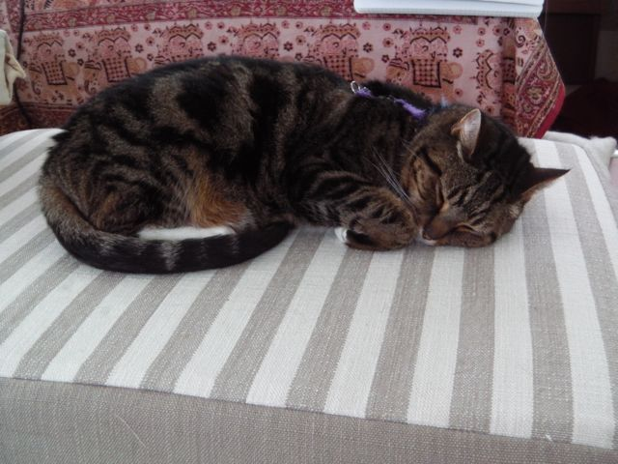

31st October 2014

What a great day! It was forecast to be 29 degrees and by 7am the sun had a bit of a kick to it (I moved into the shade to finish my breakfast). By 9.30 we were in the tinne heading for the Quarantine Station (see following photo). Entry is free but the guided tour at 11am costs $15. The word ‘quarantine’ is actually derived from a Venetian dialect of old Italian (from the 14th or 15th century depending which source you read) that means ‘40 days’ (which is the time the passengers carrying potential diseases were confined to ships). After a light lunch in the shade on Quarantine Beach we went back to Sengo to pick up our trolley and on to Manly where there is a (rather expensive) Coles. After unloading shopping we got back into the tinne and headed onto Collins Flat beach where we went for a swim – or rather I squatted under the water and did Cossack dance impressions just to keep my limbs moving (the water was chilly and I wasn’t going to stick my head under). A lovely lay in the sun (after the critical high UV period ) and back on board to finish the upstairs covers) (Busy, successful and relaxing at the same time). Sunset over Middle Harbour wasn’t bad either.

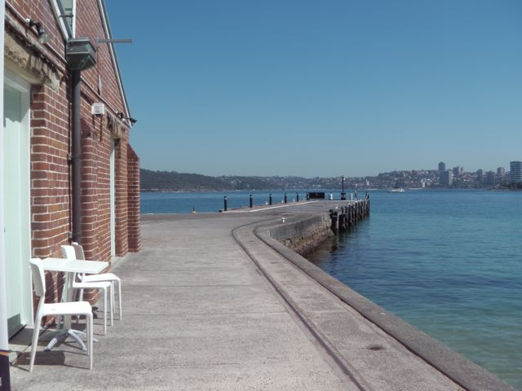
Quarantine Station Wharf

