Indochina March-April 2014
Vietnam to the Lower Mekong
25 March 2014 - 10.30pm –– Tullamarine Airport
In a newly refurbished somewhat compact lounge I manage to use the provided Wifi – no password required but don’t try to get hooked onto the router to ensure security, you need extra numbers. Junk emails deleted and bank account checked I repack the now duty free new computer, after claiming some tax back, and direct myself to the facilities. Two toilets, admittedly one for wheelchairs and no sign of the showers but I am sure they are hidden somewhere. A large tall bin obstructs access to the hand dryer so I use the disposable towels instead.
I yawn. It is my usual bedtime but as I’ve spent the past two weeks cleaning up the house ready to sell, organising details for a house-sitter, psyching myself up to get my dive certificate (of which I failed the second go) and getting ready for this trip, I am surprised I’ve lasted this long. Unfortunately the lounge chairs don’t recline. Our bags are checked through to Hanoi and I look forward to picking them up there – unlike last time I headed overseas (New Zealand doesn’t count) where, whilst the baggage was checked through to Istanbul, we arrived to find it holidaying another 36 hours in London. Subsequently, I have a backup top, underwear, deodorant and hairbrush now accompanying me in my hand luggage.
26 March 2014 - 1.20am – Tullamarine – Sngapore flight
The half glass of Bollenger Champagne, a ‘when in Rome’ occurrence as you arrive on an international business class flight, has made me a tad sleepy. I knew the full glass wouldn’t be the best for me but I’m sure the staff expected me to drink it all, or skull it in the end as I had to wave the half-filled tumbler in the air in front of them before they would take it off my hands.
The bed has been made up and I know I’m not sitting in it properly but it is not all that comfortable at present. A hot face washer was handed to us upon embarking and I’ve now had an eyeshade and slipper/socks pack passed across. Pity, I was expecting pyjamas as per my last business class flight – In fact, I specifically didn’t pack any sleeping gear based on the assumption that Singapore Airlines would probably match the earlier British Airways offering of pj’s and toiletry bags.
I have ordered the American breakfast. You could have ordered dinner if you wanted to – a steamed fish and vegies meal. At this time nuts and a bottle of water have just arrived. Maybe there are more goodies to come. Not sure if it is me – I have just been offered a second packet of nuts…funny, I was offered two rounds of papers and magazines as well…..
26 March 2014- 6am (Melbourne time) - Singapore flight
The last of the breakfast dishes have been taken away and my stomach is struggling but I am not sure whether it is because I’ve eaten about twice as much as I normally eat for breakfast or whether I’ve insulted it by feeding it at a time before I normally get up. The menu said fruit yoghurt as the first component of the American Breakfast and it was a little disconcerting when a bowl of fruit came out instead. I had to ask about the yoghurt and the stewardess assured me it would come …later. I didn’t really want the fruit, I just wanted the yoghurt – whilst I’m used to tart there was over a cup of the stuff. I also ate only half the omelette and half the tomato on the next course. Maybe this trip will be one signified by halves. Then again, two halves make a whole.
26 March 2014 - 8am – Changi Airport – Singapore
Pork Dumplings, glutinous rice and a diet coke isn’t your typical breakfast. Well, it isn’t mine and in this case it’s my second breakfast but it is currently 11am Melbourne time. Now I’ve had time to think there are some distinct differences between business class Singapore and British Airways apart from the lack of pyjamas. In Singapore Airlines the seats are not as comfortable and although it has been a while, I don’t think they are as ergonomic either; you’ve got to angle over to the side to sleep. On the plus side they seem to provide more little cupboards to stow gear, including one for reading glasses and this I was very grateful for, as I lost my glasses on the last trip. On the negative, you can’t dictate when you want to start watching a movie so if you don’t turn on immediately you will miss the start.
26 March 2014- 1.30pm - Hanoi
King sized bed in the Metropol. Vietnamese streets full of mopeds stacked to the sky with buckets, boxes, sheets of plaster, livestock, grain and family members. Rice paddies align roads between building sites, vegetable gardens, industrial buildings and lay scattered with fancy looking grave stones. Cows walk unhindered from farm area to farm area and it isn’t clear if their owners occupy the shanties falling down below the vines that line the side of the road. The city is an enigma, skinny houses sit amongst shanty towns and new multi-million dollar apartment blocks. Hanoi – between two rivers – the Red River having wound its way 500 kilometres from China with another 160 to go to the sea.
26 March 2014 - 5.15pm - Hanoi
City of the Rising Dragon – established 1010. A military museum full of captured and used wartime machinery – guns, planes, helicopters. Some interps lost in translation but a tour guide who seems passionate about his country and so much history I just never know about – then again not all of its history was of consequence to western society. The Opera House, built by French colonists, was built on over half an acre of the gardens of an earlier palace. It seems though, that unlike other nationalities at war, Vietnam seems to appreciate all years and influences of its history and strives to preserve the existing monument. At least now. There is even a standing statue of Lenin!
27 March 2014 - 2.20pm - Hanoi
Dark tan stockings, mini skirt, high heels, mobile phone to one ear, no helmet and other hand directing motor scooter so it doesn’t run into the back wheel of the bus. Welcome to Hanoi streets.
Ho Chi Minh’s mausoleum – solemn, grey, Vietnamese Star and Communist sickle, symbols that overlook the instate body of the local equivalent of a god. The emotion filled room engenders a tear – to me for no apparent reason. Guards in white uniform back up concealed cameras ensuring propriety. Orange Koi reside in the lake next to the humble domicile of Ho Chi Minh’s life, as he refused to occupy the brightly yellow covered presidential palace. (pictured)
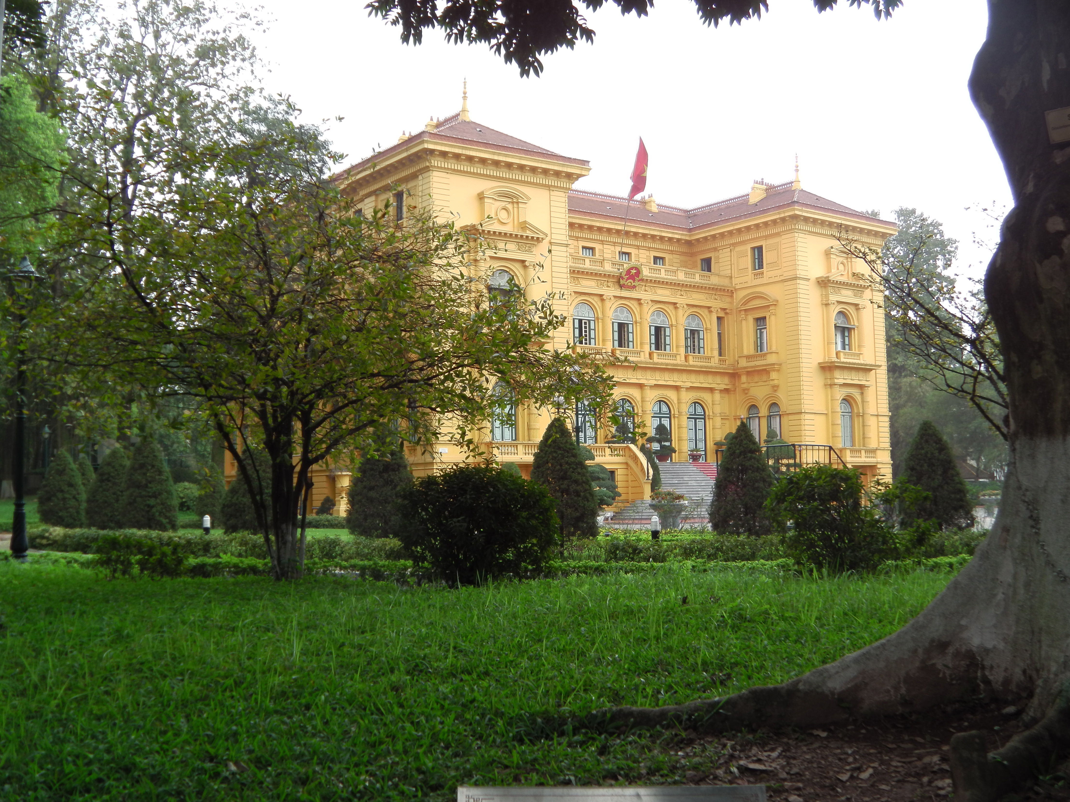
Confucius, robed in the kings colours and red and gold provided 82 rules for everyday living, whilst insisting only on the teachers hat; the crown was for the king. One of confusions’ disciples left 900.
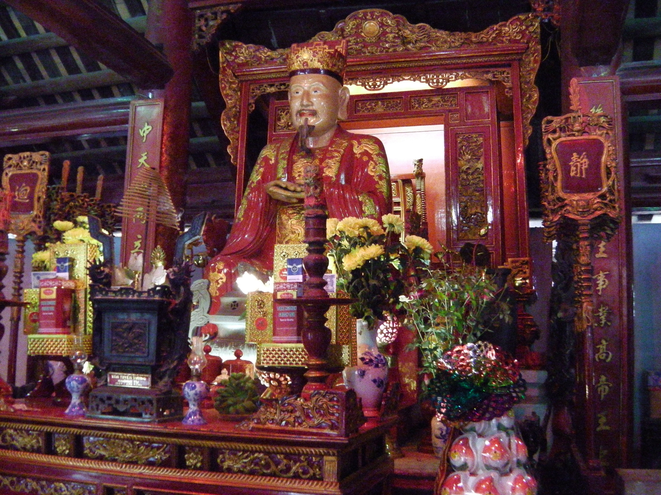
Feng Shui seems to dominate architecture, myth and culture here; a remnant of a very long Chinese occupation.
27 March 2014 - 9.30 pm - Hanoi
I’m not sure I’ve been to a stranger setup for a restaurant toilet. Upmarket and 5 star nineteen11 is a restaurant in the basement of the French built Opera House. After a meal of mixed western and Vietnam’s influence I enquired about using the facilities. Directed by a series of waiters and waitresses, like a conga line of directors, I get pointed through an opening, past mirror lined walls and through a door. The first alcove has a sink in it, the second alcove has two urinals and I hesitate. Thinking I’ve come through the wrong door I reverse my steps only to find these isn’t a second door and the waitress insists I turn back around and keep going. This is a single toilet beyond the room with the urinals. Clean and 5 star.
Today’s ride in a rickshaw gave me mixed emotions. I had been discouraged to use this form of transport, as whilst it is one way for the locals to make money from the tourists, the practice can lead to reliance and corruption. The regret I have mostly is that I didn’t get the time to walk around the Old Quarter of Hanoi; I think I would have enjoyed it more on foot. Images of street vendors, spotted tomatoes and coffee shops dominate other memories of food and vegie shops, bag shops, t-shirt shops, shoe shops. Locals have complete disregard for traffic lights.
Streets live with scooters, smaller motorcycles and bicycles, cages with canaries and bulbuls singing hang from the verandas of street shops, themselves the front room of the skinny houses where most the Hanoi city residents live.
28 March 2014 - 4pm - Ha Long Bay
Ha Long Bay – Unesco Wold Heritage Listed. Limestone kaast and schist islands representing jewels spat out by dragons in defence of the Vietnamese against the Chinese. Apparently. All I can see is fog and hear the occasional ship’s horn. As tinny as they are. We walked to the top of the Ti Top Island. I’d like to say ‘What a View’ – all I can say is ‘not a view.’
29 March 2014 - 8.55am - Ha Long Bay
The fog has lifted and I can now appreciate the landforms around me. The Tai Chi class this morning incorporated many of the warm up moves for my belly dancing so it was only the final poses that were new. A walk through Surprise Cave is vast, although I stumble off the side of the path whilst positioning for a photograph. Of course, I’ll probably not remember which one when I download them. Apparently the shower this morning in our private bathroom was nice but running out of hot water so I have forgone one. Although, now muggy from the cave walk perhaps that wasn’t the best idea. It is time to put our bags outside our door and head up for breakfast.
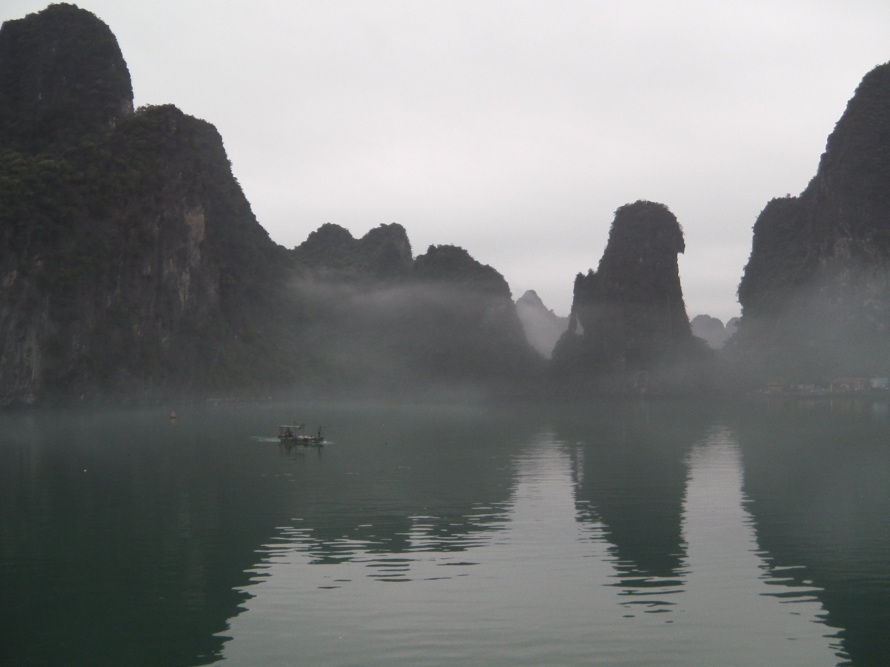
30 March 2014 - 6.30am - Saigon
I have a sore throat. I’d like to think it is a reaction to the change in temperature here. Inside the room is air conditioned and quite cool, outside is apparently hot and we arrived at 8pm last night to 28degrees C! What I’m hoping it’s not is the result of a plethora of bugs that travelled around cattle class last night on the flight Vietnam Airlines from Hanoi to Saigon. I don’t think there was a single cough-free moment.
The bus drive back to the airport yesterday took 4.5 hours and a late lunch at the airport was over catered. We consumed a major meal, were offered dinner on the plane (which I refused) and then a buffet when we got to the Sheraton – the foyer of which is way too ostentatious for me.
30 March 2014 - 6.20pm - Saigon
Waiting to go down to dinner. Had fun in market and paid a quarter of the price for cushion covers compared with yesterday – these are for a gift –same quality.
Earlier however we had a tour of the Cu Chi tunnels of the Viet Con. It was fascinating to see the war – what is known in some places here as the ‘American War’ but in the south a more complicated explanation exists – from the other side. Yes, I did crawl through three small- short – sections of the tunnel – widened for westerners, of course. The complex is over two hundred kilometres long.
Neighbours is playing on the Australian ABC television channel – naturally however, we have switched the channel to would news (BBC). The air conditioning is pleasant – outside this afternoon was stifling. This evening will be uncomfortable.
31 March 2014 - 3.20pm - RV Amalotus – My Tho
Lunch over, unpacking clothes, air conditioning on, and daily life chugging up and down the Mekong This morning’s motorbike ride unfortunately didn’t leave enough time for shopping at the market and I couldn’t believe how the time on the back of the bike went so quickly. Or maybe I can. The post office and Notre Dame on the usual tours trail. Thien Dam’s temple – the goddess of the heaven – sea goddess – was delightful 100 year old temple with daily offerings and prayers.
31 March 2014 - 10.15pm RV Amalotus – Cai Be
Slept the trip from Saigon to RV Amalotus. Slept after lunch as well. Drinks on sundeck and it is hot. A local musical group has just entertained us. 2 zithers – one a one chord zither – drums – xylophone and square guitar. I had a go on the one chord zither – love the sound. I want one!
2 April 2014 - 6am – RV Amalotus – Sa Dec
I have just watched the sunrise through a smoky haze – just as I watched it set last night. The smell is strong in the air yet no one has mentioned yet the source. Whilst the cheaper source of fuel here is rice husks (rather than gas) I find it hard to believe that burning husks are the cause. Yesterday’s excursions, which included a trip to a local brick makers, were conducted under clear skies – I won’t say blue as the skies were dominated by clouds, but there was no obvious smoke.
The silence has just been broken by the starting of an ‘outboard’ motor. The cheaper engines here are small and petrol driven and located on the end of a stick which is stored out of the water when not in use. When needed the engine is started and pushed back down into the river. Cheaper but noisier. Imagine a lawn mower.
I was offered the end of a waterlily stem to try yesterday from a market stall in the street. Tasteless. The food hygiene rules don’t exist (although I’m not dead yet – no effects from the lily) but meat was being sold (and processed in the case of fish) in the open air. Plucked, skinned and filleted. Seafood – all exposed to the humidity and heat. Poultry and red meat – and organs and offal. – all exposed to the humidity and heat. It was our afternoon excursion. The temperature was estimated to be around 35 degrees C.
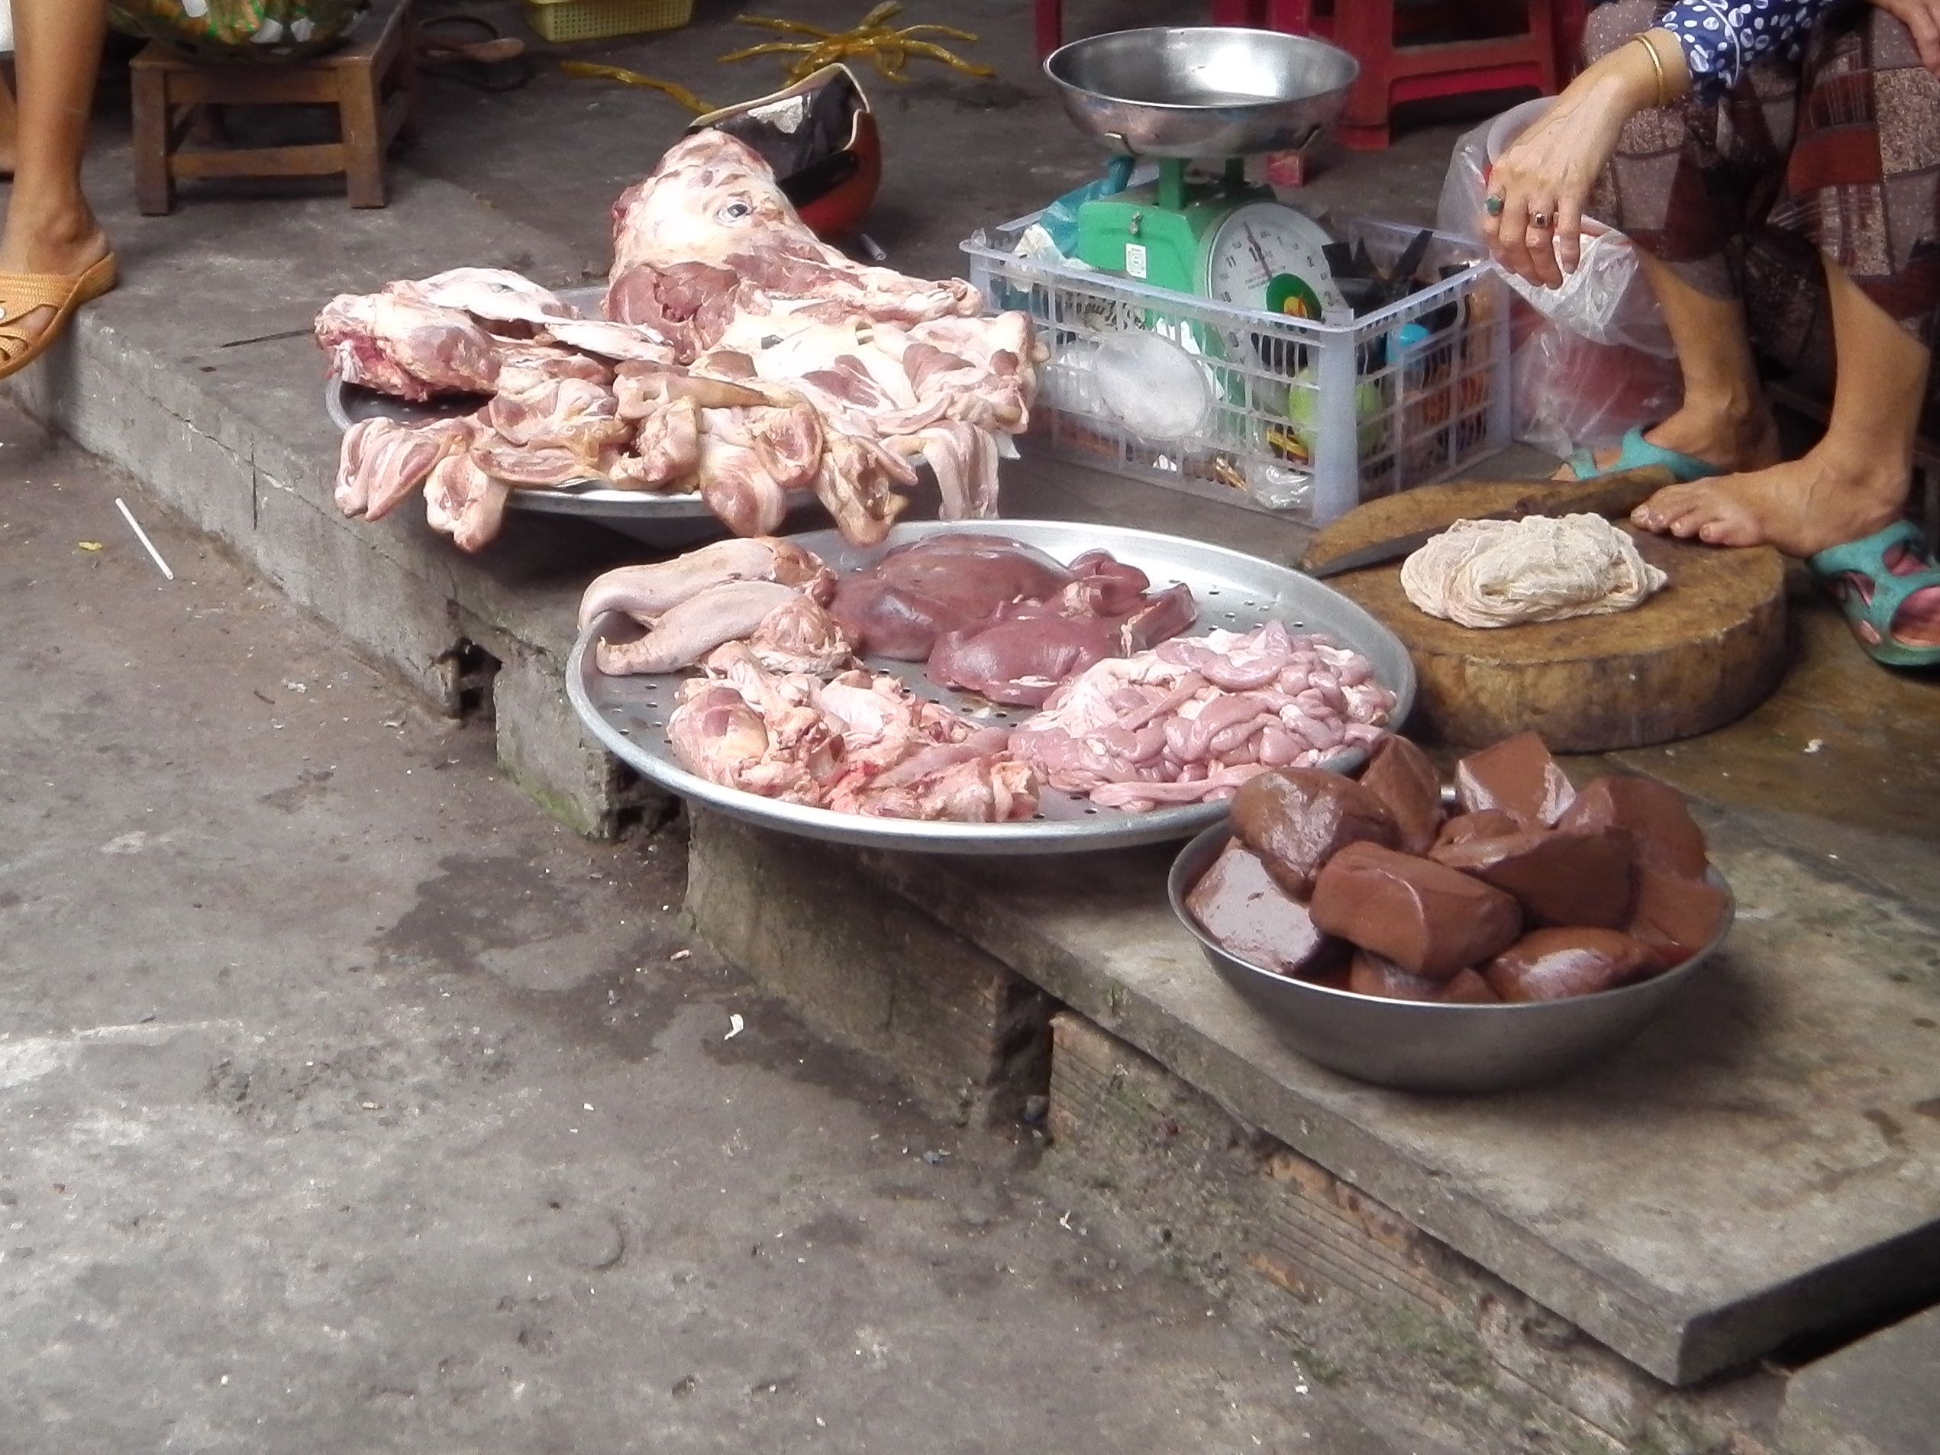
We are approaching Cambodia today and tomorrow morning we leave Vietnam.

* * * * * * * * * * * * *
Cambodia from Mekong to Angkor
3 April 2014 - 7.45am – RV Amalotus - Phnom Penh
We’ve docked and I’m looking down to a concrete jetty – which must be floating looking at the design for the steep metal ramp that leads down to it. I can hear horns so the traffic is clearly not too far away. The carpark on the bank is almost full and tourist busses line outside the restaurant facing the river. Next to this is a coffee house – “Gloria Jean’s Coffees’ a great indication that western business has reached here.
Yesterday we took a rickshaw ride from our landing point to a silk factory. Modernisation and patterns like the automatic pianos on each loom now mean that only two people are required to keep and eye on the ‘factory.’ Picking up our rides again we travelled to a mat faction – this one was working and there was a person per noisy loom feeding the reed – neutral, red or green to produce mats that are used for sitting or sleeping. I suspect these are the ones that make their way to Bunnings and I won’t be surprised to see them when I get home. All the children we met in the street said ‘hello’, probably the only word they know and some wanted to give high fives. I think the cutest thing I saw in this respect was the children of a child care centre, all at the gate of the property, all saying hello at once – looked on by their supervisor with an appropriate bemused expression.
3 April 2014 - 5.50pm - Phnom Penh
I’m not sure whether I was deigned to feel crappy this afternoon before visiting the Killing Fields but after falling asleep in the bus I awoke dazed and confused. It was also very hot and dehydration may have played a part as well as lunch as I had ostrich which perhaps has given me a similar lethargic reaction to that of turkey.
8000 skulls were in the monument we saw; some of them sorted into demographic ages and sexes. Many more were just piled high. Clothing of some of the victims was also present. Horrible. Horrible stuff. S21 was just as bad; beds with torture tools, photographs of tortured bodies and snap shots of some of the thousands of people that were brought and died there.
This morning had a lighter feel. A walk around the royal palace and a wander through the markets. I have three new pairs of pants – very colourful. I aim to go back and get some plain tops to go with them – tomorrow morning.
5 April 2014 - 6.15am - RV Amalotus - Ouknhatey Village
The sun has risen and it is cold with only 5% rain predicted yesterday we got a quick shower as we left the Phnom Penh dock and we’ve got another one overnight last night. It was clearly significant although I didn’t hear it, as the clothes we had drying on the balcony (which were almost dry) are now soaking wet. The seat covers in the middle of the sundeck covered area are also wet. The female staff member upstairs is shivering.
Having bought my pairs of pants the day before I went back to the market to get a couple of tops – one of the pants has aqua green and I decided that white was probably the best bet. In the end I got two shirts – one slightly synthetic with a middle eastern theme and a mesh upper back – and a slightly planer thicker cotton one for $4 each. I didn’t bargain – that was cheap enough – compared with the first vendor I went to – yoked long sleeve shirts – not even my style and the woman wanted $15 each as a starting price – she reduced it to $13, clearly trying to make a dollar from the Westerner, and was a bit shocked when I offered $5 for two. I didn’t buy her shirts.
Ouknhatey village was an interesting affair. We were delivered by the tuck tuk – minus suspension across dirt roads – to a silk demonstration factory and a school supported by Unicef. I didn’t buy anything at the factory and I didn’t interact with the children (or sing Waltzing Matilda to them as the majority of the group did). Not my thing.
6 April 2014 - 8am – RV Amalotus - Kampoing Cham
Yesterday I was blessed. About bloody time I hear a collective sigh. In a Buddhist temple by the river. I did not take a photo of the big Buddha overlooking the river – would feel too much like a southern Australian tourist taking happy snaps at the Big Pineapple, Banana and Prawn. The walk around the adjacent town took us to 100 year old houses – last remaining icons that survived the onslaught of the Khmer Rouge. The people seem happy enough and children have private English lessons for the equivalent of US$0.6c per day. Houses are again off the ground, and slatted bamboo floors allow cool breezes to get in. The television, radio, electric kettle and electric fans are run off a car battery. When the power runs out they pay someone to recharge it. More affluent houses have two car batteries. Fuel for cars is sold in bottles at roadside stalls.
Somewhere on the other side of the river is a loudspeaker. It has been going on for a while and I have no clue as to where it is from. We are docked to a concrete block but the walk up to this town was a slippery muddy slope. This morning three of the crew have been digging steps.
6 April 2014 - 11.40am - North Kampong Cham
Well that was the adventure I wasn’t quite expecting and I am not quite sure how to take me falling over in a Buddhist Associate Temple Complex. Is it a message? Or perhaps a prod to remember the place, where, whilst built as a temple was used for retention and execution by the Khmer Rouge. The killing filed was below and behind me. The temple was above and behind me. And a depiction of the enlightened Buddha and his five deciples was in front of me….
My right knee is bound around the broken skin. My left knee has a small bruise and I haven’t checked my lip. And I’m booked on the quad bikes the day after tomorrow…
8 April 2014 - 2.30pm - Siem Reap
I picked a great morning yesterday to have grizzly guts just before a 5 hour bus ride. Fortunately after raiding the first aid kit, I found the relevant clogging agent and dosed up. I survived the trip and we had two stops but they were extremely uncomfortable. I don’t think I’ve ever felt such heat.
Lunch was interesting. I didn’t order the focaccia at $15 because of the wheat issue so picked off the al la carte menu. We asked how big the soup was and based on that ordered a main as well. The main came out first so we sent it back. The soup then arrived – a full meal in itself. After finishing the main as well – well, most of it. I wasn’t surprised I’d put on 4kg.
Apparently the soup coming out after the main is the custom here as we discovered at The Square 24 restaurant last night. It was advertised as outside – a better description would be open air as the roof is there but the restaurant has no walls.
Yesterday we did Banyon Temple; This morning we did Ankor Wat. At the moment they are doing Ankor Ban but I’m having a break. It is warm on our balcony overlooking the garden at the Sofitel. I’ve seen a couple of birds disappear into the bushes in the garden. At 5.30 the mosquito sprayer comes around and fogs the garden. Unfortunately it kills the bees too.
* * * * * * * * * * * * *
Loas
11 April 2014 - 8am - Mekong Sun - Pak Ou
It is smoky here and there is a thick haze across the area. I’d like to say it is just due to the humidity and water in the air but unfortunately it is a smoke settling from the burning of the mountain countryside to the west of us. The hill tribes here burn the mountains to grow dry land rice, not as proficient as wet rice grown by the lowlanders. No doubt the soil will be depleted of nutrient and they will move on to destroy another patch of jungle. We arrived Luang Prabang for a latish dinner on the 9th April. The Mekong Sun is much smaller than the Amalotus and the atmosphere is much more like the junk in Ha Long Bay The classic cabins, of which we are in, have single beds, a separate bathroom, a cupboard for gear and a sliding door sized window that you can open to a balustrade to let the air flow in – only good whilst the boat is moving. I have seen several fishermen in long thin boats lie their nets across the river this morning.

12 April 2014 - 7.45am - Mekong Sun – Mekong River
Yesterday I fed an elephant. Twice. Actually, I fed two elephants twice as I had four bananas. At one point I had the entire bunch and a 20 year old elephant’s trunk was trying to get the lot without being offered any. The elephant camp is behind the village of Ban Pak Ou. They do use them to take tourist s for rides here, but if not, an elephant no longer good for work would be shot. Male elephants have their tusks consistently whittled down so they don’t become a problem. On the way back to the boat I didn’t take up the offer of a live cricket, wings taken off, for a snack. This morning however I did have a half a shot glass of local lao loa – probably a bit much after a walk through the jungle from the Pak Ou caves with minimum water.
12 April 2014 - 1.30pm
Everything has a yellow tinge and sizeable ashes fall from the sky to pollute the river below and stain the white recliner cushions on the sundeck. We can see more today – less smoke at river level and I almost wish I can’t. Burnt mountainsides will give life to one crop only before being planted out with teak.
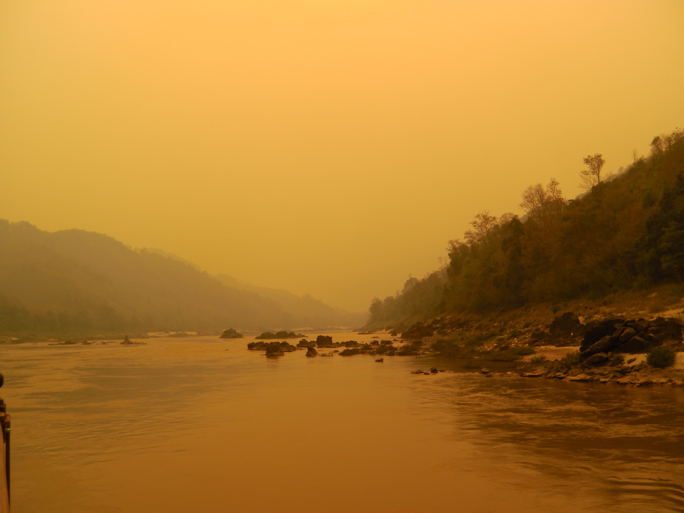
This morning’s village walk was the best I’ve done. Unpretentious, no villages trying to sell us anything. People going about their normal work. One woman was seeding kapok – collected from around the village – apparently if your mattress gets soft and indented all you do is undo the mattress cover – mix it around and re-sow the cover up again. They made festival fireworks here also – from bat guano – two boys were pounding it into black powder. I wonder how many have lost their toes doing this?

14 April 2014 - 6.30am - Luang Prabang
Yesterday, I went swimming. I finally justified bringing my togs and with a thousand other people, in the pools of the Kwang Xi Falls – it was Sunday, a very popular day and the time is a very popular time. Food stalls lined the entrance to this popular park and traffic was extremely slow. Just inside the entrance there is a bear rescue centre – occupied by cute furry black and sun bears that would otherwise have spent their lives in small circus cages.
Today is the last day of the year. It is practice here, as well as Thailand, to douse anything one sees in water, and yesterday people were practicing. We are leaving the Mekong Sun at 10am. It is the latest time that the minivan can get to the dock before the roads are blocked off for the big parade. The golden budda (Prabang Statue) is taken from Wat Xieng Thong along the streets to the Wat Mai. Market stalls fill every non-parade area and everyone will get wet. I’ve never seen water pistols quite so big!
* * * * * * * * * * * * *
Thailand
14 April 2014 - 4pm Thailand - Suvarnabhumi International Airport
I’ve just turned my phone on for the first time in a couple of weeks. Funny how being off the grid renders you invisible. Has everyone forgotten about me? Three messages have come through all from Telstra warning me off excessive charges if I was to use the phone here.
The trip to the airport this morning took one hour and the minivan was doused with lots of water; weapons varying from small water pistols and buckets from water storages on the backs of trucks though to hoses permanently set up on the side of the road, where the water source was not seen but probably linked directly into the Mekong by a Chinese built pump. Where ghetto blasters were already beyond the comfort of most ears – and that was within the buss with windows closed. Due to board plane for Chang Mai in 5 minutes.
15 April 2014 - 1010pm -Chiang Mai
Today I rode an elephant. I also got kissed by one, sat on a leg, had an elephant put a hat on my head and had a trunk hold me like a noose in the hope I might give his mahout a tip. Which I would have if I’d had any small baht notes on me. I had on 1000 and that, being the equivalent of approximately $30 would have been a very big tip indeed.
Of course there was another temple today.. and the evening was finished off with a dinner where we sat in sunken tables and enjoyed traditional northern Thai food (for tourists of course). Note – sticky rice not boiled rice!
16 April 2014 - 6.23pm - Chiang Rai
This morning started with a bang. Apparently. Technically, I didn’t hear it but as it happened when I woke up I guess that was what woke me up. The cause: the transformer the hotel was linked to blew up. No back up generator apparently. And therefore no air conditioning, no lights, no wake up call (on time, anyway) no alarm (set as a back up) and no idea whether there was going to be any breakfast. Cooked breakfast seemed a long way off. Fortunately, the power came on just as we reached the hotel restaurant.
Today was essentially a day of travel from Chiang Mail to Chiang Rai. But not before we’d seen a working herb and livestock farm (ducks, chickens, rabbits), had boat ride down the Ping River, picked up tuk tuks to get to the oldest temple in the city (640 years old) and then visited an obligatory craft factory – this time silver wear – before lunch. The three=hour bus trip was interrupted by a toilet and refreshment (happy or harmony) stop at the Cabbage and Condom rest stop and a 10 minutes at the White Temple. I didn’t go in but a couple of us rushed through. It is still a work in progress but it is beautiful!
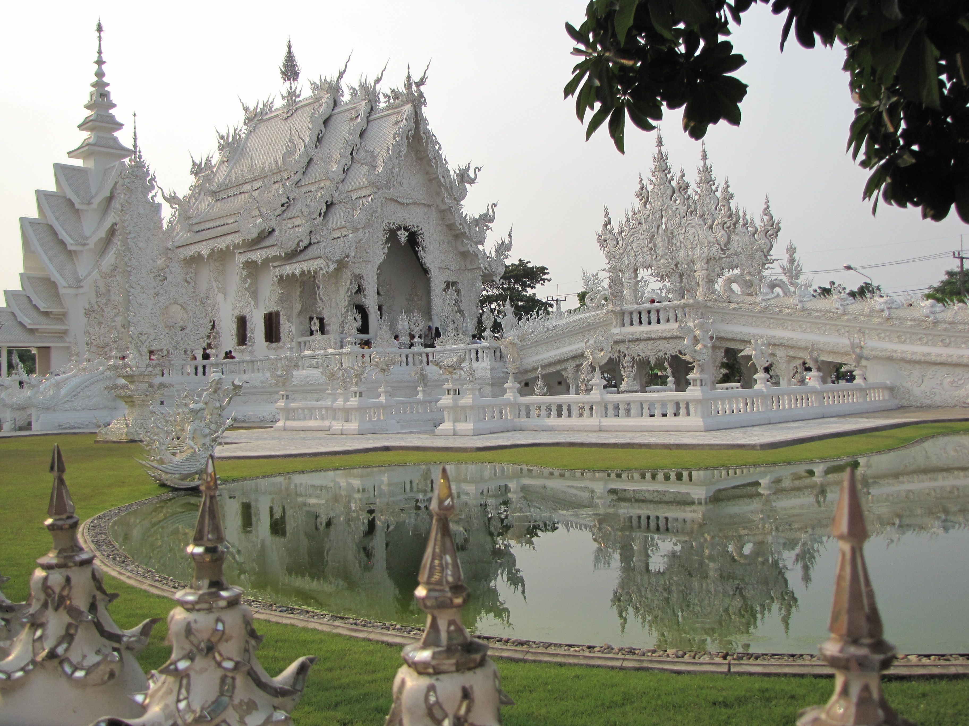
17 April 2014 - 7am - Chiang Rai
I had the best sleep. Slept right through. Perhaps it was due to the lantern release into the sky last night between the pool and the river. The buddhists light the lanterns (rice paper, wire and bamboo) and release them to the sky; the idea is to release all your troubles away into the night. It was a serene exercise and lovely watching the lanterns float up and disappear into the sky – at one point a line of four looking like a bright twinkling constellation in the dark night sky.
18 April 2014 - 10.30pm - Bangkok
Bangkok. Definitely a city of contrasts. The most obvious from the motel – air conditioning that seems freezing at 24 and stifling heat in the humid night. We’ve just been to dinner – at a restaurant called ‘The Local’. Thai food in an old house in the middle of the city – cocks in cages (and one outside in the street) probably destined for dinner. To get there we pass a range of cafes, including one called Bradmans with an ocker voice on the veranda – my guess a QLD accent. On the way back we choose a different walking route and pass a red light district, a lively lane winding away from the main street. The streets are lined with market stalls, beggars and prostitutes. Like I said – a city of contrasts!
19 April 2014 - 6pm - Bangkok
36 degrees C. 80% humidity! That was today. Hot, draining. Dripping. Another day of temples…The Grand Palace was first. Apparently it is hotter later in the morning. This is another location that needs more than a couple of hours to appreciate. The Wat Pho was next with giant reclining budda. Another large temple complex. Lunch on a barge (another buffet!) then a boat ride up the canals to a puppet show. Wat Arun was admired from the water on the way back – everyone too tired and too hot. Farewell dinner tonight…and heading home tomorrow.
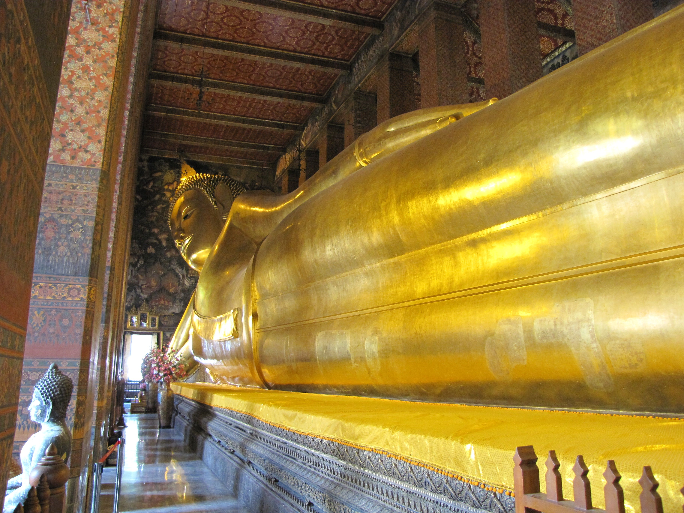
20 April 2014 – 10pm – Singapore – Changi Airport
Ahhh Singapore- Airport of the smiley face rating system for your toilet experience. Flying in, the sunset was amazing over the coast and anchored ships provided a grand view. I had to take my shirt off to get through the second lot of security and onto the flight to home. Lets hope I get some sleep before arriving at cold and wet Melbourne.

